1. Let’s take a look at the implementations.
   1. 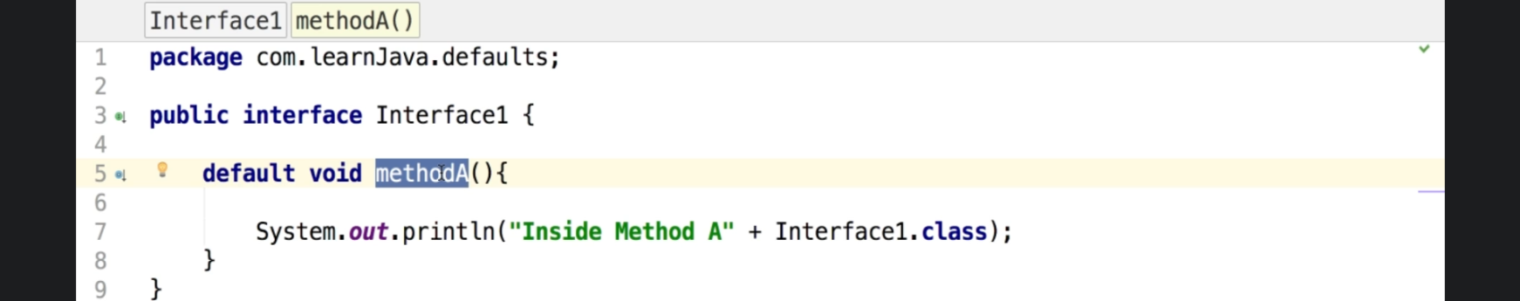
   2. 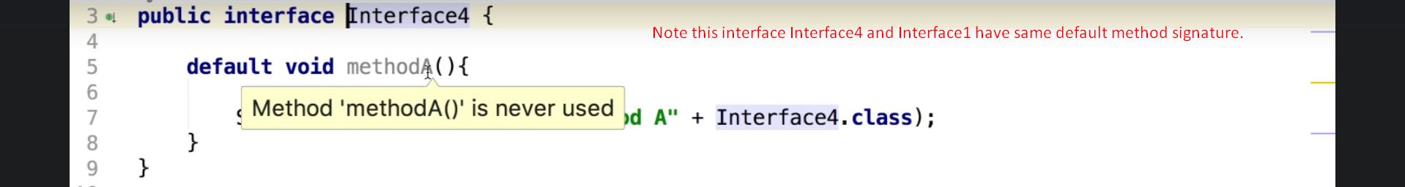
   3. 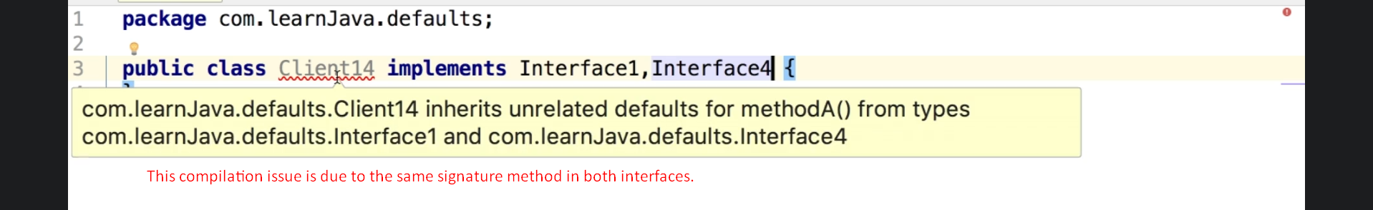
   4. 